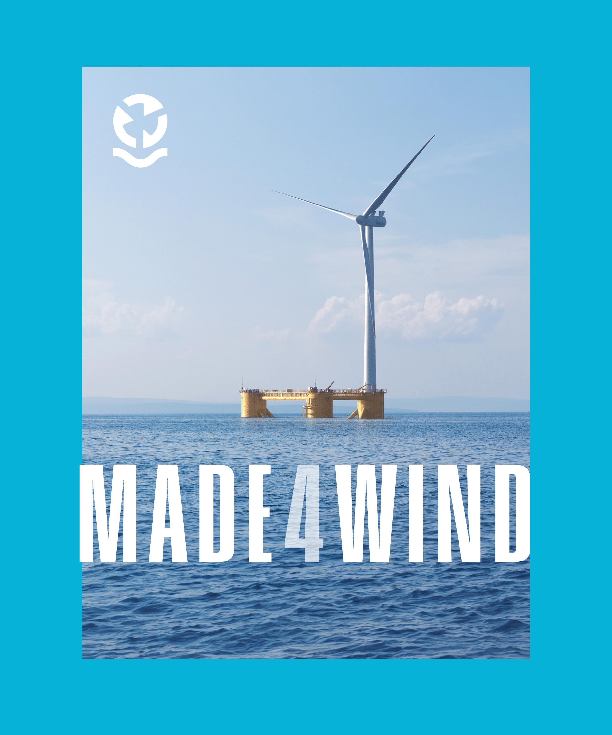
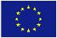
Funded by the European Union. Views and opinions expressed are however those of the author(s) only and do not necessarily reflect those of the European Union or CINEA Neither the European Union nor the granting authority can be held responsible for them.

Press Release
A Sustainable Future for Floating Wind Farms


A Sustainable Future for Floating Wind Farms: The MADE4WIND project.
- Innovative circular materials and design methods for offshore Wind Farms of the future
- MADE4WIND is made up of 11 partners from 5 different countries and has a total budget of 6 million euros funded by the European Union.

In the relentless pursuit of renewable energy, offshore wind power stands out as a beacon of hope. Yet, it faces unique challenges, particularly in the realm of large-scale floating wind turbines (FWTs). These challenges, including bulky components, limited recyclability, and environmental impact, have hindered progress. Enter the EU-funded MADE4WIND project (www.made4wind), poised to revolutionize the offshore wind energy landscape.

The project is made up of 11 partners (SINTEF, Aalborg University, Norwegian University of Science and Technology (NTNU), Siemens Gamesa, Acciona, Ingeteam, Indar, Hydro, Fibertex, IFEU (Institut für Energie-und Umweltforschung Heidelberg) and Zabala Innovation) from 5 different countries and has a total budget of 6 million euros funded by the European Union. The project began in December 2023 and will last four years. In February 2024, the partners met at the SINTEF offices in Brussels and will soon do so in Trondheim (Norway).

The MADE4WIND project is driven by a singular goal: to develop and test innovative components for a 15 MW FWT. Through pioneering designs and manufacturing techniques, the project aims to introduce breakthroughs in lightweight materials, recyclability, and advanced software tools, paving the way for a sustainable future in offshore wind energy.

Addressing Challenges

Floating offshore wind (FOW) faces formidable challenges, from enhancing platform reliability to enabling mass serial production and reducing the Levelized Cost of Energy (LCoE). Current FOW platform designs must evolve into commercial realities to accommodate larger wind turbines. Moreover, the imminent decommissioning of many offshore wind farms underscores the importance of "circularity by design" to optimize raw material usage.

Proposed Solutions

MADE4WIND is set to tackle these challenges head-on by developing and testing innovative component concepts for a 15 MW FWT. This includes advancements in blade design, substructure engineering, and drivetrain technology. By incorporating new circular lightweight materials and minimizing sea habitat impact, the project aims to increase operational availability, reduce maintenance needs, and ultimately lower LCoE, unlocking the massive deployment of >15 MW floating wind farms worldwide.

Anticipated Results

The impact of MADE4WIND extends far beyond the realm of renewable energy. By maximizing renewable deployment and electricity usage, the project contributes to the full decarbonization of Europe's energy supply. Aligned with the European Green Deal, MADE4WIND strives to create a fair, prosperous society with a modern, resource-efficient, and competitive economy. Ultimately, it envisions a future where greenhouse gas emissions are eliminated by 2050, and economic growth is decoupled from resource consumption.

The MADE4WIND project stands as a beacon of innovation, offering a glimpse into a future where sustainable energy sources power a brighter tomorrow. Through collaboration and ingenuity, it seeks to propel the offshore wind industry towards greater heights, ensuring a cleaner, greener planet for generations to come.

Contact:
Susana Garayoa
Zabala Innovation
sgarayoa@zabala.eu
T (+32) 2 5138122 · M (+32) ) 484 61 91 64
www.made4wind.eu

